A Comparative Study of BERT-Based Models for Relation Extraction in a Web-Based Seaweed Knowledge Graph Visualization System

Mursalin¹, Anne Parlina², Ahmad Tabrani³

ABSTRACT
Seaweed literature contains information related to species, bioactive compounds, biological activities, and geographic distributions. Most of this information is available in unstructured textual form, limiting direct retrieval and analysis. This paper presents a comparative evaluation of BERT-based models for relation extraction in seaweed literature and their integration into a web-based knowledge graph visualization system. A relation extraction dataset was constructed from annotated seaweed literature using four relation categories: Seaweed–Location, Seaweed–Benefit, Seaweed–Compound, and Compound–Benefit. BioBERT, SciBERT, and PubMedBERT were evaluated under the same experimental setting. Model performance was measured using Accuracy, Precision, Recall, and F1-Score. PubMedBERT obtained an Accuracy of 86.92%, Precision of 87.64%, Recall of 86.92%, and F1-Score of 87.02%, while SciBERT and BioBERT obtained F1-Scores of 85.69% and 85.17%, respectively. Predicted relations were converted into subject–relation–object triples and used for knowledge graph construction. The resulting knowledge graph was integrated into a web-based visualization system comprising literature search, entity retrieval, relation retrieval, and graph visualization components. The proposed workflow combines relation extraction and knowledge graph construction to transform unstructured seaweed literature into a graph-based knowledge representation.
Keywords: Relation Extraction; Knowledge Graph; Seaweed Literature; BioBERT; SciBERT; PubMedBERT; Information Visualization.
1. INTRODUCE
Seaweed is utilized in food, pharmaceutical, cosmetic, agricultural, and biotechnology applications. Seaweed species contain bioactive compounds such as polysaccharides, carotenoids, phenolics, and antioxidants associated with anti-inflammatory, antioxidant, antimicrobial, and anticancer activities. The volume of scientific literature on seaweed has expanded, presenting challenges in extracting and mapping relationships among seaweed species, bioactive compounds, biological activities, and geographical locations. While macro-scientometric approaches using tools like CiteSpace are applied to map global seaweed research trends, they analyze co-citation metadata rather than sentence-level entity connections [1]. The increasing number of scientific publications requires computational methods for knowledge discovery and information retrieval.
Manual literature review approaches require time and labor to identify information and establish connections between entities across multiple research articles. Automated knowledge extraction techniques provide a computational mechanism for literature exploration and mapping domain-specific bioactives [2]. Recent developments in Natural Language Processing (NLP), particularly transformer-based language models, have increased F1-scores and accuracy metrics in information extraction tasks compared to traditional rule-based methods. Relation Extraction (RE) aims to identify semantic relationships between entities within textual data. In biomedical and scientific domains, Pre-trained Language Models (PLMs) such as BioBERT, SciBERT, and PubMedBERT have been applied to extract domain-specific relationships from scientific literature. Benchmarks indicate that variations in pre-training corpora—ranging from multidisciplinary scientific texts to purely biomedical datasets—affect model accuracy in processing specialized classifications [3] and extracting interactions such as protein-protein relations [4]. Relation extraction techniques transform unstructured text into structured representations.
Knowledge Graphs (KGs) represent these structured data formats. Knowledge Graphs represent entities as nodes and relationships as edges. The integration of relation extraction and knowledge graph technologies transforms scientific literature into interconnected knowledge networks. These networks support knowledge discovery, facilitate literature exploration, and map relationships among scientific concepts within pharmaceutical and natural product informatics [5]. While relation extraction and knowledge graph construction are applied in biomedical domains, literature concerning seaweed-specific extraction is less documented. Existing studies concentrate on broader biomedical contexts; a systematic comparison of pre-trained language models for seaweed relation extraction has not been documented. Furthermore, standard graph databases often require local desktop installations or proficiency in specific query languages (e.g., Cypher, SPARQL) [6], and web-based systems designed for visualizing knowledge graphs derived from seaweed literature are limited.
Therefore, this study presents a comparative evaluation of BERT-based models for relation extraction within a web-based seaweed knowledge graph visualization system. Three transformer-based models—BioBERT, SciBERT, and PubMedBERT—are evaluated using precision, recall, and F1-score metrics on a manually annotated seaweed literature dataset. The model with the highest F1-score is subsequently integrated into an automated framework and a web interface [6] to construct and visualize knowledge graphs. This system transforms unstructured data extracted from scientific publications into an interconnected network for mapping relationships among seaweed species, bioactive compounds, health benefits, and geographical locations. The main contributions of this study are summarized as follows:
- A comparative evaluation of BioBERT, SciBERT, and PubMedBERT was conducted using standard classification metrics (precision, recall, F1-score) to evaluate transformer-based models for relation extraction in the seaweed literature domain [3],[4].
- A manually annotated relation extraction dataset was developed to document semantic relationships among entities in seaweed scientific literature, focusing on sentence-level entity connections rather than document-level metadata [1],[2].
- An automated knowledge graph construction framework was developed to convert extracted textual relationships into structured graph representations [5].
- A web-based knowledge graph visualization system was designed and implemented to map entities and relations extracted from seaweed scientific literature [5],[6].
2. RELATED WORK
The increase in seaweed research publication volume requires computational tools for literature mining and knowledge extraction. While macro-scientometric approaches and bibliometric tools map global research trends using co-citation metadata [1], these methods process document-level metadata rather than sentence-level interactions between biological entities. Extracting specific connections among seaweed species, geographical locations, and bioactive compounds requires semantic analysis algorithms capable of processing unstructured text. Relation Extraction (RE) is a Natural Language Processing (NLP) task designed to identify and classify semantic relationships from unstructured text [7]. The application of Transformer-based Pre-trained Language Models (PLMs), including BioBERT, SciBERT, and PubMedBERT, has altered the methodological framework of RE [3].
The performance of these models, measured by standard classification metrics such as F1-score, is determined by their pre-training corpora. Comparative evaluations of these models are required to identify which architecture yields the highest precision and recall for specific textual domains. Previous research indicates that variations in training corpora influence a model's capacity to process specialized domain terminologies [8]. PLMs are primarily trained on broad biomedical datasets and are less frequently evaluated on marine and agricultural literature, which presents distinct multi-entity classification challenges. The development of corpora such as BioRED [9] indicates a requirement for extraction systems capable of processing interactions across text sequences. To organize the relations extracted by PLMs, Knowledge Graphs (KGs) are utilized to represent data structures as interconnected nodes and edges. Standard graph databases utilized for KG storage often require local installations or specific query languages (e.g., SPARQL, Cypher), which presents operational constraints for users without query programming backgrounds [5].
Additionally, literature indicates that RE model evaluation and KG construction are often conducted as separate tasks within standardized benchmark environments [8], rather than being integrated into specific web applications. Web-based systems specifically designed for seaweed literature informatics are limited. To address these methodological constraints, this research conducts a comparative study of BERT-based models to quantify their relation extraction performance on seaweed texts. The model producing the highest evaluation metrics is subsequently integrated into a web-based visualization system to map the extracted multi-entity relations.
3. METHODOLOGY
  - Research Framework
This section outlines the methodological framework for the comparative evaluation of BERT-based models and the development of the web-based seaweed knowledge graph visualization system. The methodology comprises seven phases: data acquisition, relation annotation, model development, model evaluation, knowledge graph construction, system integration, and data visualization. Initially, a corpus of scientific publications is compiled and manually annotated. This approach aligns with literature stating that organizing scientific information into structured knowledge bases requires the extraction of scientific entities and their relations [10]. The resulting annotated dataset serves as the baseline for training and evaluating the transformer-based relation extraction models. Subsequently, the model yielding the highest F1-score is deployed to generate structured relational data from the literature corpus. In the final phase, the extracted relations are synthesized into a knowledge graph and integrated into a web-based visualization interface for data exploration and semantic analysis.

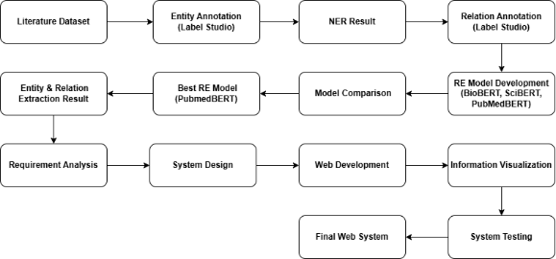

Figure 1. Research methodology framework
  - Data Collection
This study utilizes a seaweed literature dataset obtained from the National Research and Innovation Agency (BRIN), Research Center for Data and Information Sciences. The dataset consists of scientific literature collected from the Scopus database and serves as the primary data source for the information extraction process. The collected literature provides the foundation for identifying entities and semantic relationships, which are subsequently used to construct the Named Entity Recognition (NER) and Relation Extraction (RE) datasets
Table 1. Data Characteristics
Characteristic | Description
Data Source | National Research and Innovation Agency (BRIN), Research Center for Data and Information Sciences
Database | Scopus
Domain | Seaweed Literature
Number of Documents | 1,122 Documents
Data Format | CSV
Language | English
Data Content | Article Metadata and Abstracts
Purpose | Named Entity Recognition (NER) and Relation Extraction (RE)

  - Relation Annotation
The relation annotation process was conducted manually on the collected seaweed literature to construct a supervised dataset for relation extraction, an approach consistent with established text-mining methodologies where relations are annotated from scratch by hand to ensure high data quality [4]. Four entity categories were defined based on the characteristics of seaweed-related scientific information: Seaweed, Location, Benefit, and Compound. Similar to existing data-driven approaches that determine a specific set of key entities and relations most representative of their domain [4], these defined entities capture the essential seaweed species, geographical information, biological activities, and bioactive compounds discussed in the literature.

Table 2. Annotated entity categories
Entity | Description
Seaweed | Name of a seaweed species or type
Location | Research location or geographical origin of seaweed
Benefit | Biological activity or benefit associated with seaweed
Compound | Bioactive compound contained in seaweed

After entity identification, semantic relationships between entity pairs were annotated according to predefined relation types. The annotation focused on four primary relations that were subsequently used for relation extraction model training.
Table 3. Relation types used in annotation
Relation | Description
Seaweed–Location | Indicates the origin, habitat, or research location of a seaweed species
Seaweed–Benefit | Indicates biological activities or benefits associated with a seaweed species
Seaweed–Compound | Indicates compounds contained in a seaweed species
Compound–Benefit | Indicates biological activities or benefits produced by a compound

The complete annotation process produced 10,284 relation instances. The distribution of all annotated relations is presented in Table 4.
Table 4. Distribution of annotated relations
Relation | Count
Seaweed–Compound | 4,100
Compound–Benefit | 3,213
Seaweed–Benefit | 2,068
Seaweed–Location | 786
Compound–Compound | 40
Benefit–Compound | 38
Seaweed–Seaweed | 18
Benefit–Benefit | 12
Compound–Seaweed | 8
Benefit–Location | 1
Total Relations | 10,284

Only the four predefined primary relations were retained for relation extraction model training. The remaining relation types appeared infrequently and were excluded to reduce class imbalance and maintain a consistent relation schema. The final training dataset contained 10,167 relation instances, as summarized in Table 5.
Table 5. Relation types used for RE model training
Relation | Count
Seaweed–Location | 786
Seaweed–Benefit | 2,068
Seaweed–Compound | 4,100
Compound–Benefit | 3,213
Total Relations Used | 10,167
Although the annotation process produced various relation categories, this study only utilizes relations that are aligned with the predefined information extraction objectives. Therefore, the construction of the RE dataset is focused on four main relation categories, namely the relationships between Seaweed and Location, Seaweed and Benefit, Seaweed and Compound, and Compound and Benefit. These four relation categories were selected because they represent the most relevant information in seaweed literature studies.
  - Relation Extraction Model
This study conducts a comparative evaluation of three domain-specific transformer-based architectures: SciBERT, BioBERT, and PubMedBERT, for the Relation Extraction (RE) task. The objective is to compute semantic relationships between entity pairs using contextual representations generated from tokenized inputs, specifically input_ids and attention_mask. The transformation of raw text into token indices follows the standard transformer encoding pipeline [11]. To establish a controlled experimental environment for baseline comparison, all candidate models are trained using a supervised learning approach under identical hyperparameter configurations: a batch size of 16, a learning rate of $2 \times 10^{-5}$, a weight decay of 0.15, and a maximum limit of 5 training epochs.The dataset is partitioned into 17,195 samples for training and 1,911 samples for validation per epoch.
During training, each batch undergoes forward propagation to output relation class predictions, followed by loss computation against ground-truth labels. Model parameters are updated through backpropagation. To prevent overfitting, an early stopping strategy with a patience parameter of 1 is implemented. Validation loss is calculated at the end of each epoch. If the validation loss does not decrease, training is terminated, and the model weights corresponding to the minimum validation loss are restored to ensure structural evaluation based on empirically observed loss metrics.
  - Model Evaluation
The evaluation of the Relation Extraction (RE) models was conducted using standard classification metrics, including Accuracy, Precision, Recall, and F1-score. These metrics were used to measure the model’s ability to correctly classify relation categories in a multi-class setting. Accuracy refers to the proportion of correctly predicted samples out of the total dataset. Precision measures the proportion of correctly predicted instances for each class, while Recall measures the proportion of relevant instances that are successfully identified by the model. The F1-score is defined as the harmonic mean of Precision and Recall, providing a single measure that balances both metrics[12].
The metrics are defined as follows:

$$Accuracy=\frac{TP + TN}{TP+TN+FP+FN}$$

$$Precision=\frac{TP}{TP+FP}$$

$$Recall=\frac{TP}{TP+FN}$$

$$F1=2×\frac{Precision×Recall}{Precision+Recall}$$

where TP represents true positives, TN represents true negatives, and FP represents false positives, and FN represent false negatives.
Since the task involves multiple relation classes, both macro-averaged and weighted-averaged scores are reported to provide a more balanced evaluation across classes with different distributions. Macro-averaging treats all classes equally, while weighted-averaging accounts for class frequency in the dataset. All models (SciBERT, BioBERT, and PubMedBERT) are evaluated on the same held-out test set to ensure a fair comparison. The F1-score is used as the main metric for comparing model performance across relation categories.
  - Knowledge Graph Construction
The knowledge graph is built from the entities and relations produced by the Relation Extraction (RE) models. In this graph, entities are represented as nodes, and relations are represented as directed edges between two nodes [13]. The graph uses four entity types: Seaweed, Location, Compound, and Benefit. It includes four relation types: Seaweed–Location, Seaweed–Benefit, Seaweed–Compound, and Compound–Benefit. The construction process converts each predicted relation into a triplet format (head entity, relation, tail entity) [14]. These triplets are directly used to form the graph structure. To maintain data quality, duplicate relations are removed and entity names with the same meaning are standardized. The final output is a knowledge graph that connects seaweed-related concepts in a structured form.
  - Web-Based System Development
The web-based system is developed to visualize the results of relation extraction and knowledge graph construction[15]. The system integrates processed data into a graph-based interface. The system consists of data processing, backend, and visualization components[16]. The data processing module handles outputs from the relation extraction stage. The backend organizes and structures the data for graph representation. The visualization component displays entities as nodes and relations as edges. The interface allows users to view and explore connections between entities through graph interaction[17]. The system is implemented as a web application to enable browser-based access.
4. RESULT AND DISCUSSION
4.1 Relation Extraction Performance
The performance of the Relation Extraction models in this study was evaluated using four standard classification metrics: Accuracy, Precision, Recall, and F1-Score. This evaluation aims to assess the models' capability to recognize and classify entity relationships into five predefined categories (No Relation, Seaweed–Location, Seaweed–Benefit, Seaweed–Compound, and Compound–Benefit). This section presents a detailed overview of the training results, evaluation metrics, and confusion matrices for the three transformer models tested: SciBERT, BioBERT, and PubMedBERT SciBERT (allenai/scibert_scivocab_uncased), configured with BertForSequenceClassification (109,922,309 trainable parameters), was evaluated on a held-out test set of 1,911 samples. Table X and Figure Y summarize the training progression. The model converged at epoch [Value], where the validation loss reached a minimum of [Value], triggering early stopping. At this optimal epoch, SciBERT achieved a macro-averaged F1-score of [Value]% and an overall accuracy of [Value]%.

Table 6. SciBERT Training Performance
Epoch | Training Loss | Validation Loss | Accuracy (%) | Precision (%) | Recall (%) | F1-Score (%)
1 | 0.870326 | 0.491176 | 83.36 | 83.64 | 83.36 | 83.43
2 | 0.412088 | 0.413442 | 85.56 | 86.21 | 85.56 | 85.69
3 | 0.302321 | 0.448630 | 85.87 | 87.29 | 85.87 | 86.08

Training loss decreased from 0.870326 in the first epoch to 0.302321 in the third epoch, indicating model convergence on the training set. Conversely, validation loss reached a minimum of 0.413442 at the second epoch before increasing to 0.448630 in the third epoch. This divergence suggests that further training past the second epoch led to overfitting rather than generalization. Consequently, the second epoch represents the optimal training point, balancing training convergence and validation performance.
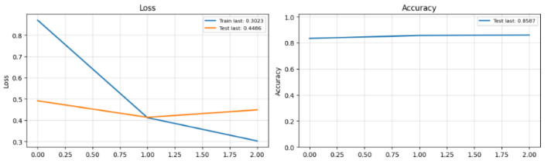
Figure 2. Grafik Loss and Accuracy Model SciBERT
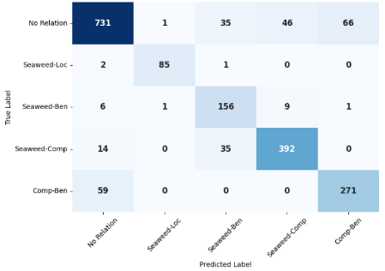
Figure 3. Confusion Matrix Model SciBERT
The model from the second epoch was selected via early stopping due to its minimum validation loss. This configuration yielded an accuracy of 85.56%, a precision of 86.21%, a recall of 85.56%, and an F1-score of 85.69%. The diagonal dominance within the confusion matrix confirms that the majority of samples were correctly classified, indicating the model's capacity to differentiate the five predefined relation categories.
The evaluation subsequently proceeded with the BioBERT model (dmis-lab/biobert-base-cased-v1.1), utilizing the BertForSequenceClassification architecture with 108,314,117 trainable parameters. The variation in parameter count relative to SciBERT is due to differences in vocabulary size; BioBERT employs a case-sensitive BERT-base-cased vocabulary structure, which alters the embedding matrix dimensions. Testing was performed on the same held-out set of 1,911 samples

Table 7. BioBERT Training Performance
Epoch | Training Loss | Validation Loss | Accuracy (%) | Precision (%) | Recall (%) | F1-Score (%)
1 | 0.960425 | 0.552405 | 78.60 | 79.53 | 78.60 | 78.02
2 | 0.435343 | 0.453248 | 83.73 | 84.86 | 83.73 | 83.99
3 | 0.324958 | 0.428929 | 84.88 | 86.30 | 84.88 | 85.17
4 | 0.250992 | 0.441361 | 85.56 | 86.29 | 85.56 | 85.69

The training loss decreased from 0.960425 in the first epoch to 0.250992 in the fourth epoch, indicating model convergence on the training set. Conversely, the validation loss reached a minimum of 0.428929 at the third epoch before increasing to 0.441361 in the fourth epoch. Based on the minimum validation loss criterion, the model weights from the third epoch were selected via early stopping. At this optimal configuration, BioBERT achieved an accuracy of 84.88%, a precision of 86.30%, a recall of 84.88%, and a macro-averaged F1-score of 85.17%.
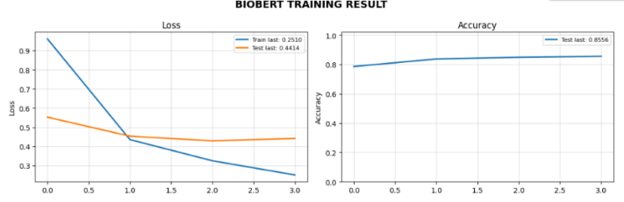
Figure 4. Grafik Loss dan Accuracy Model BioBERT
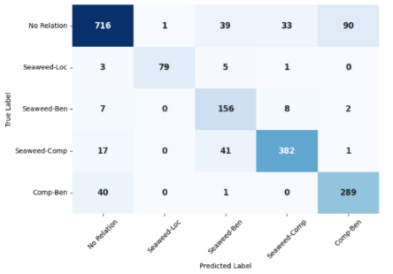
Figure 5. Confusion Matrix Model BioBERT
The diagonal dominance within the confusion matrix confirms that the majority of samples were correctly classified across the five predefined categories (No Relation, Seaweed–Location, Seaweed–Benefit, Seaweed–Compound, and Compound–Benefit). This distribution demonstrates the model's capacity to differentiate semantic relationships while minimizing cross-category misclassifications.
The final model evaluated was PubMedBERT (microsoft/BiomedNLP-PubMedBERT-base-uncased-abstract-fulltext), utilizing the identical 1,911-sample test set. Configured with BertForSequenceClassification, it contains 109,486,085 trainable parameters; the variance from previous models is attributed to its uncased vocabulary pre-trained from scratch on PubMed articles, which alters the embedding matrix dimensions

Table 8. PubMedBERT Training Performance
Epoch | Training Loss | Validation Loss | Accuracy (%) | Precision (%) | Recall (%) | F1-Score (%)
1 | 0.849350 | 0.490908 | 82.37 | 82.38 | 82.37 | 81.86
2 | 0.383749 | 0.434934 | 85.35 | 86.75 | 85.35 | 85.56
3 | 0.294770 | 0.403423 | 86.92 | 87.64 | 86.92 | 87.02
4 | 0.231449 | 0.428107 | 88.02 | 88.46 | 88.02 | 88.07

Training loss decreased from 0.849350 (epoch 1) to 0.231449 (epoch 4). Validation loss reached a minimum of 0.403423 at epoch 3 before increasing to 0.428107 at epoch 4, indicating overfitting. Early stopping was consequently applied at epoch 3. At this optimal configuration, PubMedBERT yielded an accuracy of 86.92%, precision of 87.64%, recall of 86.92%, and a macro-averaged F1-score of 87.02%
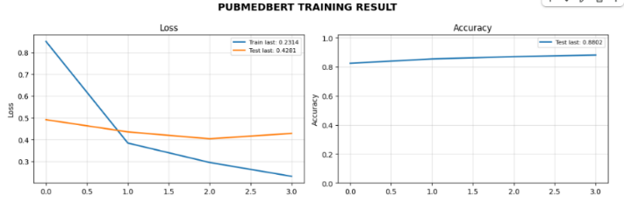
Figure 6. Grafik Loss dan Accuracy Model PubMedBERT

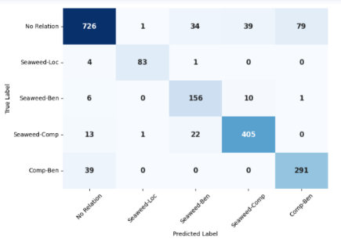

Figure 7. Confusion Matrix Model PubMedBERT
The diagonal values indicate that most samples across the five categories (No Relation, Seaweed–Location, Seaweed–Benefit, Seaweed–Compound, and Compound–Benefit) were correctly classified. Quantitatively, PubMedBERT yielded the highest evaluation metrics among the tested models, with minimal cross-category misclassifications.
4.2 Comparison of SciBERT, BioBERT, and PubMedBERT
To determine the optimal architecture for the relation extraction (RE) task, a comparative analysis of SciBERT, BioBERT, and PubMedBERT was conducted. Performance was evaluated on the identical test set using accuracy, precision, recall, and F1-score.

Table 9. Performance Comparison of the Evaluated Models
No | Model | Accuracy (%) | Precision (%) | Recall (%) | F1-Score (%)
1 | BioBERT | 84.88 | 86.30 | 84.88 | 85.17
2 | SciBERT | 85.56 | 86.21 | 85.56 | 85.69
3 | PubMedBERT | 86.92 | 87.64 | 86.92 | 87.02

As detailed in Table 9, PubMedBERT yielded the highest metrics across all evaluation parameters, achieving an accuracy of 86.92%, a precision of 87.64%, a recall of 86.92%, and an F1-score of 87.02%. This quantitative advantage indicates a greater generalization capacity for extracting semantic relations compared to SciBERT and BioBERT. Consequently, PubMedBERT was selected as the final architecture for the relation extraction system to facilitate the construction of the seaweed literature knowledge graph.
4.3 Knowledge Graph Construction Results
The relation predictions generated by the PubMedBERT model were utilized to construct the knowledge graph. The graph is structured using semantic triples (subject, relation, object), where each triple denotes a predicted semantic relationship extracted from the literature corpus

Table 10. Extracted Triples for Knowledge Graph Construction
Subject (Entity) | Relation Type | Object (Entity)
C. hypnaeoides | Seaweed–Location | Japan
C. hypnaeoides | Seaweed–Compound | Polysaccharide
C. hypnaeoides | Seaweed–Benefit | ameliorate insulin resistance
Polysaccharide | Compound–Benefit | ameliorate insulin resistance
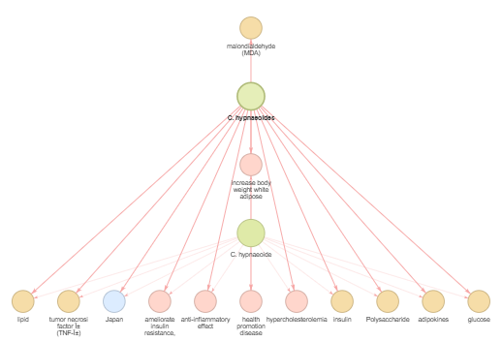
Figure 8. Visualization of the Constructed Knowledge Graph.
The knowledge graph models the relationships between entities as a network structure. Nodes denote the extracted entities, while edges represent the predicted relations connecting them. This visualization maps the interdependencies among seaweeds, compounds, benefits, and locations.
4.4 Web-Based Visualization System
The extracted entities and relations were integrated into a web-based application for structured information retrieval from the seaweed literature corpus.
4.4.1 System Architecture
The application architecture is divided into two modules: a Home Page for data management and a Visualize Page for data representation. This framework supports the processing, storage, and rendering of the extracted entities and relations within a web interface.
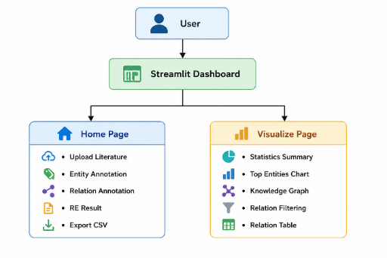
Figure 9. System Architecture
4.4.2 Data Management Interface
The Home Page functions as the data ingestion and processing interface. The implemented modules include document uploading, entity and relation annotation, rendering of the Relation Extraction (RE) outputs, and data exportation to CSV format. This interface centralizes the preprocessing and extraction phases.

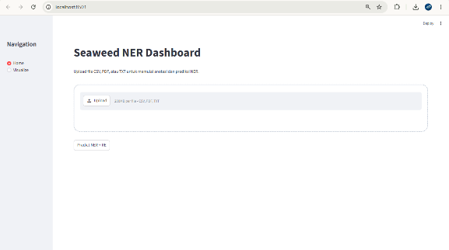
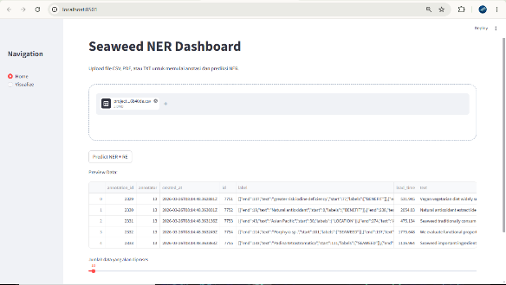
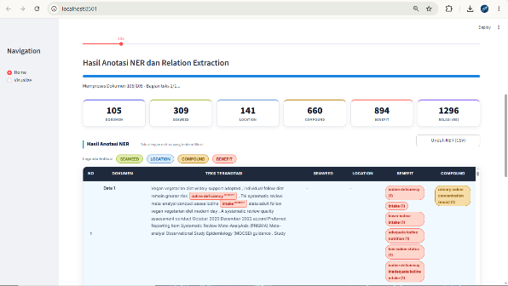
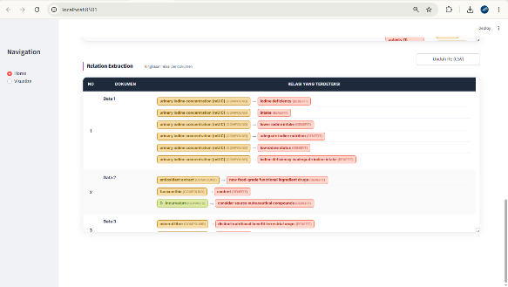

Figure 10. Home Page Interface
4.4.3 Analytical and Statistical Visualization
The Visualize Page aggregates the extracted data into quantitative representations. A Statistics Summary module reports numeric metrics, including the total count of processed documents, extracted entities, generated relations, and unique entity types. An Entity Distribution chart illustrates the occurrence frequency of each extracted category within the dataset.

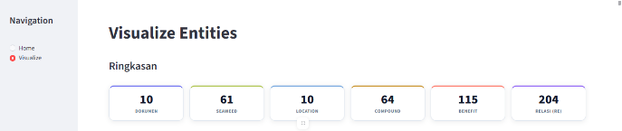
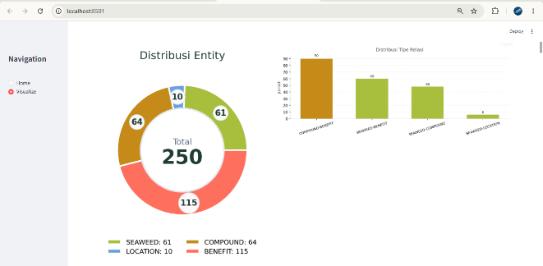
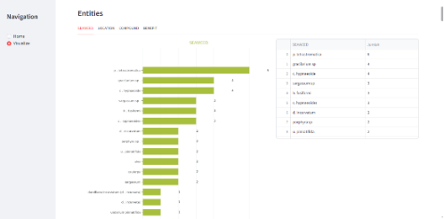
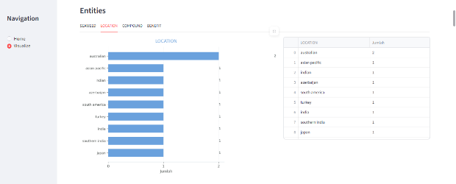
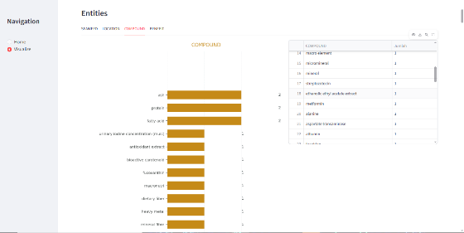
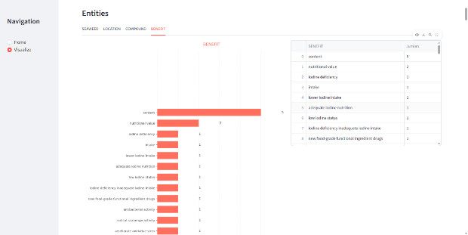

Figure 11. Statistics Summary and Entity Distribution Charts
4.4.4 Relational Filtering and Network Visualization
A Relation Filtering module permits users to isolate data based on relation types or source documents. The filtered data is presented in two formats: a tabular Relation Table for record inspection, and a network visualization (Knowledge Graph). In the graph visualization, nodes denote the extracted entities (seaweeds, compounds, benefits, locations), and edges represent the predicted semantic relations.

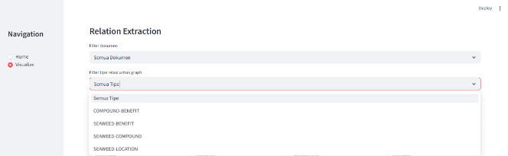
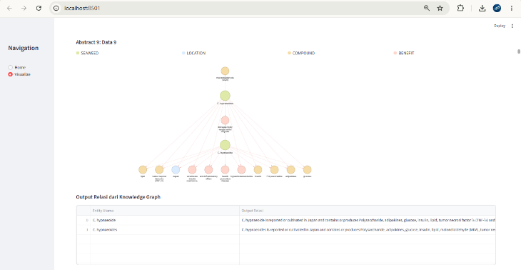
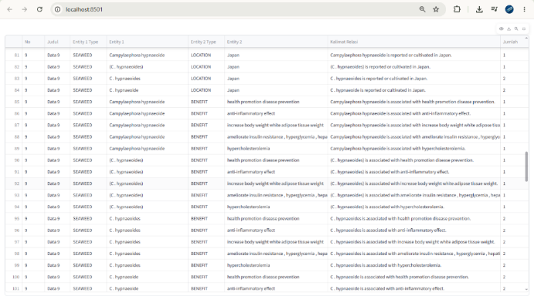
Figure 12. Network Visualization, Relation Filtering, and Relation Table
4.5 DISCUSSION
4.5.1 Comparison of BERT-Based Models
The evaluation results indicate differences in relation extraction performance among BioBERT, SciBERT, and PubMedBERT. PubMedBERT achieved an Accuracy of 86.92%, Precision of 87.64%, Recall of 86.92%, and F1-Score of 87.02%. SciBERT achieved an Accuracy of 85.56%, Precision of 86.21%, Recall of 85.56%, and F1-Score of 85.69%. BioBERT achieved an Accuracy of 84.88%, Precision of 86.30%, Recall of 84.88%, and F1-Score of 85.17%. The difference between the highest and lowest F1-Score was 1.85 percentage points, while the difference between the highest and lowest Accuracy was 2.04 percentage points.
Across all reported metrics, PubMedBERT ranked first, SciBERT ranked second, and BioBERT ranked third. The three evaluated models differ in their pre-training corpora. PubMedBERT was pre-trained on PubMed literature, SciBERT was pre-trained on scientific publications from multiple disciplines, and BioBERT was further pre-trained on biomedical corpora after initialization from BERT. In this study, no additional experiments were conducted to isolate the effect of pre-training data on model performance. Therefore, the comparison is limited to the observed evaluation results obtained on the same relation extraction dataset and experimental configuration. Based on the reported Accuracy, Precision, Recall, and F1-Score values, PubMedBERT was selected as the relation extraction model for the subsequent knowledge graph construction and web-based visualization stages.
4.5.2 Implications for Knowledge Graph Construction
The outputs of the Relation Extraction (RE) model constitute the structural components of the resulting knowledge graph. The knowledge graph is constructed by converting predicted relations into subject–relation–object triples; consequently, classification outputs during the extraction phase determine the final graph topology. Structural variations in the knowledge graph correspond directly to the false positive and false negative rates in the RE model predictions.
A false positive produces an unverified edge—such as linking a seaweed species to an unannotated geographic location or bioactive compound—creating a structural link not present in the source dataset. A false negative results in a missing edge, where an annotated connection between entities is excluded from the graph. PubMedBERT obtained a Precision of 87.64% and a Recall of 86.92%. In the context of graph construction, the 87.64% Precision score indicates that 12.36% of the generated edges represent false positives. The 86.92% Recall score indicates that 13.08% of the relationships annotated in the source text are excluded from the graph as false negatives. The implementation of PubMedBERT yields a knowledge graph with a structural composition defined by these measured operational parameters and quantified error rates.
4.5.3 Practical Implications of the Visualization System
The integration of the PubMedBERT relation extraction model with the web-based visualization interface constitutes a system for querying extracted seaweed literature. The relation extraction model processes unstructured scientific text to output subject–relation–object triples. The web application subsequently maps these predicted triples into a graphical layout, rendering biological and geographic entities as nodes and their extracted relationships as edges. The system's search functionality accepts input parameters, including specific seaweed species or biological activities, and returns the corresponding relational network. This graphical output displays connected bioactive compounds, biological benefits, and geographic locations as an interactive structure. Through this pipeline, the integrated extraction and visualization components transform raw scientific text into a structured, queryable data format, bypassing the requirement for manual document parsing.
4.5.4 Limitations and Future Work
The operational scope of the relation extraction and knowledge graph visualization system is constrained by the methodological parameters established during the training phase. The dataset utilized for model evaluation consists exclusively of annotated texts sourced from seaweed literature. Applying the current PubMedBERT architecture to process unstructured texts from divergent marine or botanical domains requires the integration of supplemental annotated corpora.
The classification schema allocates inputs strictly into four predefined categories: Seaweed–Location, Seaweed–Compound, Seaweed–Benefit, and Compound–Benefit. Semantic variables outside this specified schema—such as temporal sequences, extraction methodologies, and dosage measurements—are omitted from the extraction pipeline and the final knowledge graph topology. Subsequent research designs necessitate the expansion of the training corpora to increase the scope of processable domains. The methodological framework will be modified to integrate additional semantic categories into the classification schema. Planned experimental protocols include the application of alternative model architectures to calculate structural variations in false positive and false negative rates during the graph construction phase.
5. CONCLUSION
BioBERT, SciBERT, and PubMedBERT were evaluated for relation extraction in seaweed literature using a dataset containing four relation categories: Seaweed–Location, Seaweed–Benefit, Seaweed–Compound, and Compound–Benefit. PubMedBERT obtained an Accuracy of 86.92%, Precision of 87.64%, Recall of 86.92%, and F1-Score of 87.02%, compared with F1-Scores of 85.69% for SciBERT and 85.17% for BioBERT. Consequently, PubMedBERT was selected for the relation extraction stage. Predicted relations were converted into subject–relation–object triples for knowledge graph construction.
The resulting knowledge graph was integrated into a web-based visualization system comprising literature search, entity retrieval, relation retrieval, and graph visualization components. Entities are represented as nodes and relations as edges, providing a graphical representation of relationships among seaweed species, compounds, biological activities, and geographic locations extracted from the literature.
The presented framework combines relation extraction and knowledge graph visualization within a single workflow for seaweed literature. Future work may involve expanding the annotated corpus, incorporating additional relation categories, integrating automatic named entity recognition modules, and evaluating alternative language model architectures. Further development of the web application may include automated literature ingestion, periodic knowledge graph updates, advanced search and filtering functionalities, graph analytics features, and support for larger-scale knowledge graphs.
6. REFERENCES
[1] T. Chandra, M. Nor, M. I. Mohd, J. Xu, Z. Abdul, and L. Seong, “Heliyon Knowledge mapping analysis of the global seaweed research using CiteSpace,” Heliyon, vol. 10, no. 7, p. e28418, 2024, doi: 10.1016/j.heliyon.2024.e28418.
[2] M. Maskur, A. A. Prihanto, M. Firdaus, and R. Nurdiani, “Potential of seaweed bioactives for pharmaceutical applications,” vol. 14, no. 1, pp. 0–3, 2026.
[3] S. Handayani and D. Toresa, “Evaluating Contextual Embedding Models for Multi-Label PICO Classification in Heart Disease : Addressing the Intervention - Comparison Bottleneck,” vol. x, no. 2, pp. 84–95, 2025.
[4] M. Basmaci, J. Zheng, C. Jemiyo, J. Hur, and A. Ozg, “Data and text mining Evaluating GPT and BERT models for protein – protein interaction identification in biomedical text,” no. September, 2024.
[5] J. E. Evangelista, A. D. Lutsky, A. I. Byrd, D. J. B. Clarke, A. Prabhakaran, and S. L. Jenkins, “Creating an Interactive Web Interface for Networks Stored in Knowledge Graph Databases,” pp. 1–43, 2025, doi: 10.1002/cpz1.70200.
[6] R. Rocha and G. Â. De Lima, “Deigmata : A User-Centered Visualization Tool for Knowledge Graph Exploration,” vol. 52, no. 8, 2025.
[7] Y. Lee, J. Son, and M. Song, “BertSRC : transformer ‑ based semantic relation classification,” BMC Med. Inform. Decis. Mak., vol. 5, pp. 1–18, 2022, doi: 10.1186/s12911-022-01977-5.
[8] Y. Jia, H. Wang, Z. Yuan, L. Zhu, and Z. Xiang, “Biomedical relation extraction method based on ensemble learning and attention mechanism,” BMC Bioinformatics, 2024, doi: 10.1186/s12859-024-05951-y.
[9] L. Luo, P. Lai, C. Wei, C. N. Arighi, and Z. Lu, “BioRED : A Rich Biomedical Relation Extraction Dataset,” no. Ddi.
[10] Y. Luan, “Multi-Task Identification of Entities , Relations , and Coreference for Scientific Knowledge Graph Construction,” pp. 3219–3232, 2018.
[11] T. Wolf et al., “Transformers : State-of-the-Art Natural Language Processing,” pp. 38–45, 2020.
[12] D. M. W. Powers, “Evaluation : From Precision , Recall and F-Factor to ROC , Informedness , Markedness & Correlation,” no. December, 2007.
[13] C. Gutierrez and J. F. Sequeda, “Knowledge graphs,” Commun. ACM, vol. 64, no. 3, pp. 96–104, 2021, doi: 10.1145/3418294.
[14] S. Ji, S. Pan, E. Cambria, P. Marttinen, and P. S. Yu, “A Survey on Knowledge Graphs: Representation, Acquisition, and Applications,” IEEE Trans. Neural Networks Learn. Syst., vol. 33, no. 2, pp. 494–514, 2022, doi: 10.1109/TNNLS.2021.3070843.
[15] K. Sun, Y. Liu, Z. Guo, and C. Wang, “EduVis: Visualization for education knowledge graph based on web data,” ACM Int. Conf. Proceeding Ser., pp. 138–139, 2016, doi: 10.1145/2968220.2968227.
[16] S. Latif et al., “Visually Connecting Historical Figures Through Event Knowledge Graphs,” Proc. - 2021 IEEE Vis. Conf. - Short Pap. VIS 2021, pp. 156–160, 2021, doi: 10.1109/VIS49827.2021.9623313.
[17] D. Riva and C. Rossetti, “Visualization of Knowledge Graphs with Embeddings: an Essay on Recent Trends and Methods,” 2024, [Online]. Available: http://arxiv.org/abs/2412.05289

